Walk 29 Malvern Hills
Last walked in December 2017

Description. A 9 km (5.6 mile) walking along good tracks and minor roads through woodland and across part of the Malvern Hills.
Start. Hollybush (A438) Explorer Map 190. Grid 759369.
Directions from Whitecross Roundabout (Turn milometer to zero). Take the A4110 Canon Pyne (Three Elms road) for 1 mile and TR at the traffic lights onto the A4103 Worcester (Roman road). After 7.7 miles TR, signposted to Stoke Edith. After 9 miles TL at road junction (not sign posted) onto main road to Ledbury. Reach roundabout at 15.9 miles and go straight across heading for the Town Centre. Go through town centre and TL at traffic lights onto the A449 to Malvern and Worcester (total 17 miles). After 1 mile LR onto the A438 to Eastnor and Tewkesbury (total 18 miles). After 2.9 miles just past the Hollybush signpost, on the left is a car parking area with a Countryside Information Board in it (total 21 miles).

1. Car Park. With your back to the main road, cross over a cattle grid and walk up a tarmac road/drive to ‘Peacock Villa’, which is about 1½ km away. (As you walk up the road, (that soon loses its tarmac), away over on the left hand side can be seen Eastnor Obelisk, a 90 foot high memorial to various distinguished members of the Somers Cocks family, the greatest of whom was John Somers, Lord Chancellor in 1700 and adviser to William of Orange who arrived from the Netherlands with the Glorious Revolution in 1688. Another is Philip James Cocks, an intelligence officer on Wellington’s staff, who died at the siege of Burgos in the Peninsular War on 8th October 1812). Before reaching ‘Peacock Villa’ the road/drive goes through a metal gate and starts to descend, and at the bottom is a cattle grid. Just before the cattle grid, (don’t go over it) you TR, through a metal gate, (or gap), and into the woods, and walk along a prominent dirt track. After about ½ km you reach a cattle grid, and there is a small wooden gate at the top of the bank on your right, go through that gate and veer off slightly to the right (east) as you follow an indistinct track up and out of the woods, onto the open hillside and up to the ridge top, where there is a low level, stone concreted direction indicator post that points to: Obelisk - Midsummer Hill, British Camp, and so on. When you get to the top of the ridge you TL.

2. Direction Post. Walk along the ridge of the Malvern hills, keeping in the same direction for about 2 kms, to reach a car park on the A449. Firstly you reach a T-junction in the track at ‘Hangman’s Hill’, and TL to continue along the ridge. You then pass a small cave on your right called ‘Clutter’s Cave’, (used to be called Giants Cave, but the name of Clutter was taken from a hermit who lived there some centuries ago). You then get to cross tracks by a stone concreted direction indicator post, and go straight across, keeping to a track that goes down and around the right hand side of the British Camp. (The British Camp is an Iron Age hill fort located at the top of Herefordshire Beacon in the Malvern Hills. The fort is thought to have been first constructed in the 2nd century BC. A Norman castle was built on the site. The extensive earthworks remain clearly visible today and determine the shape of the hill. The height of the summit of British Camp is 1,110 feet). Keep on this track that’s goes down to the car park, passing a reservoir that’s over on your right hand side.
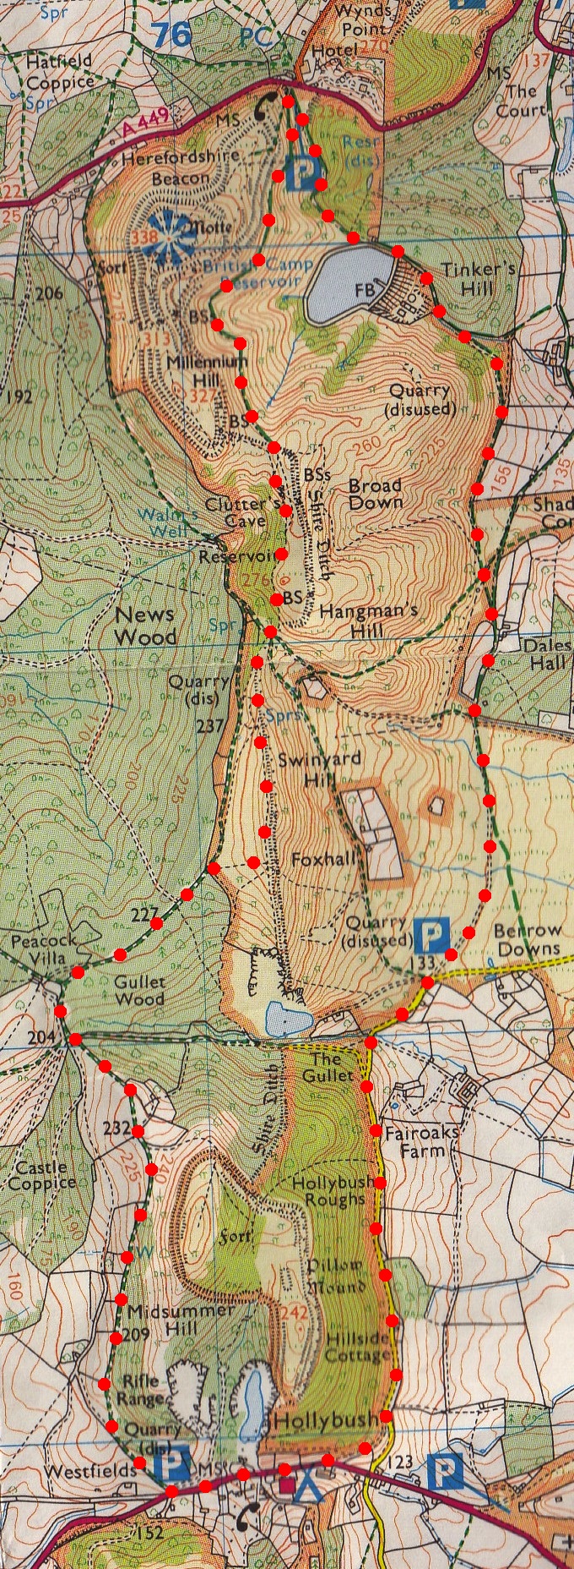
3. Herefordshire Beacon Car Park. Once you have gone through the wooden gate into the car park, you turn hard right, (almost back on yourself) to walk down to the bottom corner and cross a cattle grid, then continue down a tarmac lane, heading for the reservoir. Go past the reservoir that’s on your right and on down a very steep concrete drive, and then onto a dirt track into the woods. The track bends to the right across a brook and continues up a slight incline, heading south. You come out into the open, and keeping in the same direction follow the track that heads for the farm buildings/houses in front and slightly to the left. On reaching the houses you continue on south, along wide track/drive and pass the houses on your left. Continue along the track/drive and when it bends left you carry straight on, and go along a Public Bridleway, (ignore the track that’s veers off to the right). For about ½ km you go across rough swampy ground, keeping in the same direction and very slightly to the right, to reach a minor road at Swinyard Car Park.
3

4. Swinyard Car Park. TR and go along the minor road, (ignore the tarmac lane on your right). After about 1 km and not far past a house on your left (roughly 300m), you veer off up a well defined dirt track on your right that initially goes in the same direction, then bends right to meet a main road. TR and walk up along the road to the brow of the hill and to the car.
2

1
4

